MACH4METAL

metalworking machinery
Transito 21, 6909 DA Babberich, Netherlands
Tel. + 31 (0)316 – 247123
Fax. + 31 (0)316 - 247956
info@mach4metal.com
www.mach4metal.com
Bank No : 66.52.13.883
IBAN : NL33 INGB 0665 2138 83
BIC : INGBNL2A
VAT : NL 815393635B01

MAZAK INTEGREX E-650 H MILL TURN

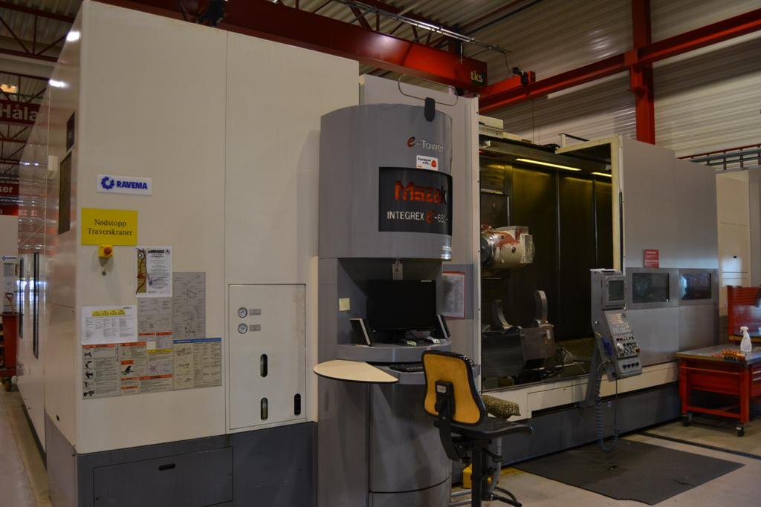
- Make : MAZAK - Yamazaki
- Type : INTEGREX E-650H
- Serial NO : 161900
- Age : 2002 . 12

- Capacity
- Max. swing Ø : 920
- Machining swing Ø : 420
- DBC turning length : 4.000
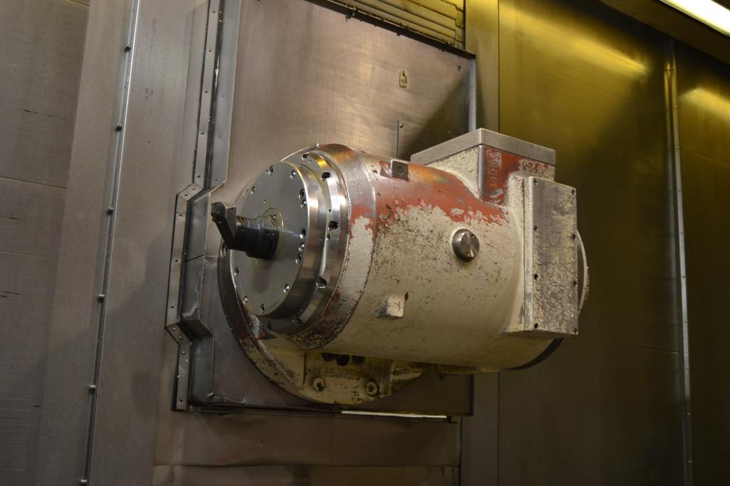
- Spindle bore : 170
- X travel : 260
- Z travel : 150
- Spindle speed : 1.600
- Power : 30 kW
- Speeds : 3.300

- Rapid feed X :
- Rapid feed Z :
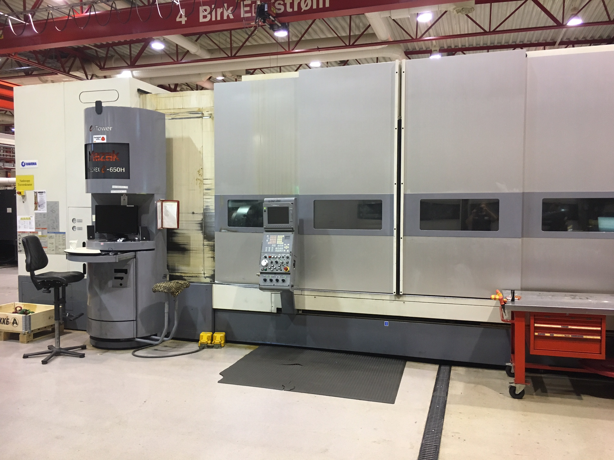
- Revolver : 12 Positions
- Speeds live tool : 4.000 Rpm
- Power live tools : 8 kW

- Dimensions
- Length :
- Width : 1.700
- Height : 2.200
- Weight : 32.000 Kg

- MAZATROL MATRIX NEXUS
- C Axis
- Tool eye
- SMW Steady rest

Please Note: The above information has been obtained to the best of our ability and belief from, and from the manufacturers where possible. It is given in good faith, but its accuracy can not be guaranteed. Accordingly, it will not form a representation or constitute contractual terms. We advise you to check any vital details

